GBUR ID STAFF CARDS INFORMATION 2026
 | ID: GBUR-2026-001
 | Names: RUKUNDO Samson
 | Position: General Secretary
 | Department: General Secretariat Office
 | Work Field: GBUR Office - Kigali City
 | Phone: +250 788 613 494
 | Email: rukundos.rs@gmail.com
 | Validity: September 2026 – December 2027
 | IFES Region: EPSA

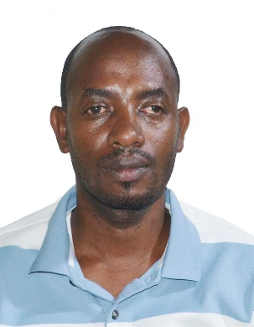 | ID: GBUR-2026-002
 | Names: SHYAKA Alex
 | Position: National Students Ministry Coordinator
 | Department: Students Ministry
 | Work Field: GBUR Office – Kigali City
 | Phone: +250 782 481 444
 | Email: ashyaka72@gmail.com
 | Validity: August 2026 – December 2027
 | IFES Region: EPSA

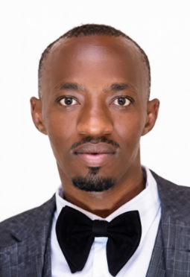 | ID: GBUR-2026-003
 | Names: TUMUSIME Enos
 | Position: National Discipleship Coordinator & Campus Staff
 | Department: Students Ministry
 | Work Field: GBUR Office & Eastern Region | Campuses: UR Nyagatare Campus and EAUR Nyagatare Campus
 | Phone: +250 786 722 669
 | Email: enotum6@gmail.com
 | Validity: August 2026 – December 2027
 | IFES Region: EPSA

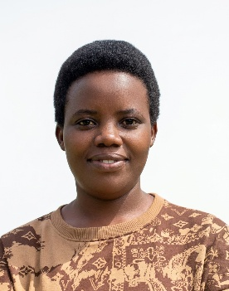 | ID: GBUR-2026-004
 | Names: UMUHOZA Susan
 | Position: Accountant
 | Department: Finance
 | Work Field: GBUR Office – Kigali City
 | Phone: +250 787 876 521
 | Email: dmurenzisuzan@gmail.com
 | Validity: August 2026 – December 2027
 | IFES Region: EPSA

 | ID: GBUR-2026-005
 | Names: DUKUZUMUREMYI David
 | Position: PA – Office Staff
 | Department: General Secretariat Office & Graduates Ministry
 | Work Field: GBUR Office – Kigali City
 | Phone: +250 791 354 739
 | Email: davidduk03@gmail.com
 | Validity: August 2026 – December 2027
 | IFES Region: EPSA

 | ID: GBUR-2026-006
 | Names: NIYIHORAHO Heroic
 | Position: IT Officer
 | Department: Information and Technology
 | Work Field: GBUR Office – Kigali City
 | Phone: +250 784 358 517
 | Email: heroicrwand@gmail.com
 | Validity: August 2026 – December 2027
 | IFES Region: EPSA

 | ID: GBUR-2026-007
 | Names: MANISHIMWE Xavier (Enzo)
 | Position: Resource Mobilization Officer
 | Department: Graduates Ministry
 | Work Field: GBUR Office – Kigali City
 | Phone: +250 785 594 222
 | Email: enzoxavier072@gmail.com
 | Validity: August 2026 – December 2027
 | IFES Region: EPSA

 | ID: GBUR-2026-008
 | Names: IRADUKUNDA Aime
 | Position: Campus Staff
 | Department: Students Ministry
 | Work Field: Kigali Region | Campuses: ULK Kigali Main Campus and RP Kigali - Rutongo Campus
 | Phone: +250 780 721 712
 | Email: aime1iradukunda2@gmail.com
 | Validity: August 2026 – December 2027
 | IFES Region: EPSA

 | ID: GBUR-2026-009
 | Names: KAKAZI Nuliathe
 | Position: Campus Staff
 | Department: Students Ministry
 | Work Field: Kigali Region | Campuses: UR Remera Campus, AHSU Kigali, UNILAK Kigali Campus
 | Phone: +250 783 865 268
 | Email: kazenuliath@gmail.com
 | Validity: August 2026 – December 2027
 | IFES Region: EPSA

 | ID: GBUR-2026-010
 | Names: GIHOZO Emeline
 | Position: Campus Staff
 | Department: Students Ministry
 | Work Field: Kigali Region | Campuses: UR Nyarugenge Campus, UR Gikondo Campus, and EACC
 | Phone: +250 791 069 048
 | - Email: emelynegihozo6@gmail.com
 | Validity: August 2026 – December 2027
 | IFES Region: EPSA

 | ID: GBUR-2026-011
 | Names: USANASE Hyacinthe (Isimbi)
 | Position: Campus Staff
 | Department: Students Ministry
 | Work Field: Kigali Region | Campuses: RP Kigali College, UoK Kacyiru Main Campus, UoK Remera Campus, and UTB Kigali Main Campus
 | Phone: +250 780 936 071
 | Email: hausanase@icloud.com
 | Validity: August 2026 – December 2027
 | IFES Region: EPSA

 | ID: GBUR-2026-012
 | Names: KIIZA Isaac
 | Position: Campus Staff
 | Department: Students Ministry
 | Work Field: Southern Region | Campuses: UR Huye Campus, RP Huye College, ICK Muhanga, CUR Save Campus and CUR Taba Campus
 | Phone: +250 784 667 443
 | Email: isaackiiza70@gmail.com
 | Validity: August 2026 – December 2027
 | IFES Region: EPSA

 | ID: GBUR-2026-013
 | Names: MANZI Ivan
 | Position: Campus Staff
 | Department: Students Ministry
 | Work Field: Northern Region | Campuses: RP Tumba College and UTAB Byumba Main Campus
 | Phone: +250 786 973 824
 | Email: ivanmanzi01@gmail.com
 | Validity: August 2026 – December 2027
 | IFES Region: EPSA

 | ID: GBUR-2026-014
 | Names: NIYOMUKIZA Patrick
 | Position: Campus Staff
 | Department: Students Ministry
 | Work Field: Northern Region | Campuses: UR Busogo Campus, RP Musanze College, INES Ruhengeri, and UoK Musanze Campus
 | Phone: +250 784 781 067
 | Email: patrickniyomukiza47@gmail.com
 | Validity: August 2026 – December 2027
 | IFES Region: EPSA

 | ID: GBUR-2026-015
 | Names: BYIRINGIRO David
 | Position: Campus Staff
 | Department: Students Ministry
 | Work Field: Eastern Region | Campuses: UR Rukara Campus, RP Ngoma College, UR Rwamagana Campus, and UNILAK Rwamagana Campus
 | Phone: +250 789 045 563
 | Email: byiringirodavid49@gmail.com
 | Validity: August 2026 – December 2027
 | IFES Region: EPSA

 | ID: GBUR-2026-016
 | Names: TUYIRATE Sadoki
 | Position: Campus Staff
 | Department: Students Ministry
 | Work Field: Western Region | Campuses: RP Karongi College, Kibogora Polytechnic Nyamasheke Main Campus & Rusizi Campus
 | Phone: +250 780 167 766
 | Email: sadokituyirate2@gmail.com
 | Validity: August 2026 – December 2027
 | IFES Region: EPSA

